
UNITED EAST LOTHIAN AGRICULTURAL SHOW

SATURDAY 28th June 2025
AT EAST FORTUNE, NORTH BERWICK, EH39 5JX
TRADE STAND BOOKING FORM – ZONE 2
To be completed and returned with all documentation by – 16th May 2025
Trading Name
Address
Post Code
Contact Name & Tel No(s)
Email address(s)
Description of
Business
Zone | 2 |  |  | Total Cost
Frontage (metres) |  |  |  | £
Compulsory – Medical Cover per trade stand |  |  | £5.00

Trade Stand  Erection | Friday | Saturday | Are you bringing a Generator? (Must be silent) | Yes/No

Are you a registered Charity | Yes |  | No
If Yes provide charity no: | Charity Number

The following documents MUST be submitted with this Trade Stand Application Form:
Documentation |  | Attached
Copy of the Company’s current/in-date Public Liability insurance certificate to the value of £2million - (Employers Liability will NOT be accepted)
A Completed Risk Assessment Form
Food Hygiene Certificate if Applicable (Please note that for any stands offering food for sale we may request further documentation)
Registered Charity Documentation if Applicable
Trade Stand Declaration Form duly signed
Additional Admission  Tickets - £7.50 each | Nos Required | Total Cost
 | Once all Documentation is received and your application has been accepted an invoice will be forwarded for payment.
I have read and understood the Trade Stand Information & Rules included on this form and agree to adhere to the rules of the UELAS.
Signature ……………………………………………………………………………………… Date …………………………………….

UNITED EAST LOTHIAN AGRICULTURAL SHOW
SATURDAY 28th June 2025
AT EAST FORTUNE, NORTH BERWICK, EH39 5JX

TRADE STAND PRICING GUIDE AND LAYOUT

Your booking will not be accepted unless this form has been completed correctly and all documentation requested is submitted.

Please note any applications without correct documentation will not be accepted, as they will then not comply with East Lothian Council’s requirements.

Forms and associated documents must be returned by email to admin@haddingtonshow.co.uk

by 16TH May 2025

Please note that due to the increasing demand for trade space; failure to send in applications by this date may result in your application being declined.

Enquiries – email: admin@haddingtonshow.co.uk

ZONE 2 | Min/Max Metre Frontage |  | Incrementation | Depth | Standing | Price per Linear Metre
*Min. Price £90.00 | From 4m- 20m |  | 1m increments | 10m | Grass | 18.50 p/m
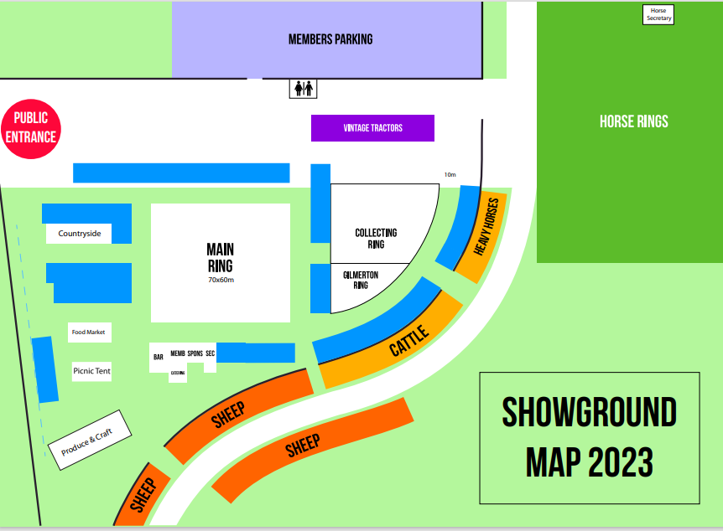

TRADE STAND INFORMATION
AND RULES

Please read these conditions carefully before signing the declaration form.

*********************
- Exhibitors hire space at the Haddington Show at their own risk.

- Exhibitors will be issued with admission passes and windscreen labels for their personnel and essential vehicles as follows:

Between 40 & 99 m2 | 2 x Adult Passes & 1 x Car Pass
Between 100 & 199m2 | 4 x Adult Passes & 1 x Car Pass
200m2+ | 6 x Adult Passes & 2 x Car Pass

Additional windscreen passes are not available due to space restrictions. Exhibitors must ensure that provision is made for all contractors, suppliers and their staff who may be required to attend on Show Day. The Society advises that extra admission passes for the above mentioned must be purchased. Admission to the Showground will not be permitted unless an Admission Ticket is presented.

Additional Admission tickets can be purchased at a cost £7.50 per ticket.

- All Exhibitors have the responsibility to ensure that nobody is injured on their stand. Therefore, all Exhibitors must complete a risk assessment for their stand to identify any potential risks and if applicable, take steps to reduce the likelihood of injury occurring.
- All liability on Trade Stands lies with the particular Exhibitor who is responsible for obtaining his/her own Public Liability Insurance to the value of £2million. All stands at the Haddington Show must be covered by Public Liability Insurance, a copy of which must be attached to this application.

- An Exhibitor reserves the right to cancel their stand, however notice must be in writing and the following will apply even if a Stand is resold or reallocated.
  - Within 8-7 weeks of the date of the Show – 90% of any payment made (10% for admin costs)
  - Within 6-5- weeks of the date of the Show – 50% of any payment made
  - Within 4-0 weeks of the date of the Show – No refund of any payment made.
.
If for any reason the Exhibitor does not turn up on Show Day and use the Stand at the Show, the Society will be under no obligation to refund the Fee to the Exhibitor

- The allocation of position of the Stand is on a “first come first served” basis and rest entirely with the Society, although every endeavour will be made to meet any reasonable request by the Exhibitor regarding the position of the Stand or any special requirements.

- Exhibitors will be responsible for the removal of all refuse from their site. Skips and waste bins will be positioned around the Show Ground for use by exhibitors and the public. There will be a fine of up to £100 for any exhibitor who leaves refuse on their stand.
- The Society will not be responsible for any accident involving implements, machines or other articles belonging to any Exhibitor and it is a condition of entry that each Exhibitor shall hold the Society blameless for, and indemnify it against, any legal proceedings arising from any accident caused by Exhibitors or their employees or exhibits.

- All Exhibitors display equipment, stock, goods etc entirely at their own risk and the Society will under no circumstances be liable for any loss or damage occurring thereto.

- No Exhibitor will be permitted to arrange a stand or place signs in such a manner as to obstruct or inconveniently affect the display of any other Exhibitor. Signs and guy ropes must not be allowed to project beyond the space allocated. Space reserved must allow for this. Infringements of this regulation will be dealt with by the Stewards, who are empowered to remove the cause of the offence or to have the stand rearranged at the expense of the Exhibitor.

- Trading from Stands must be restricted to within the designated area applied for in the application form and no exhibitor shall sub-let the whole or any part of the space allocated.

- The Exhibitor must be mindful of any risk that members of the public may be put to, when visiting its Stand, and to take appropriate action. All Display Vehicles parked on the Stand must not be used for demonstration purposes and all keys must be removed. Chocks on wheels must be in place and handbrakes applied to exhibits otherwise secured. Hydraulics must be secured by either being parked in the “low” position, or by placing mechanical “scotches” to prevent downward motion.

- By Law, all enclosed public spaces (this includes marquees) must be kept SMOKE FREE. Council Smoking Inspectors, who are not employed by the Society, may attend and will issue a fine if someone is smoking in an enclosed area. The Society will not be liable for this fine.

- Exhibitors will have access to their Stand from 09.00 am on Friday 27th June 2025. All Stands must be set up no later than 8.45 am on Saturday 28th June 2025. Exhibitors setting up on Saturday morning will have access to the Showground from 7.00 am and must be set up and ready for business by 9.00am. All service vehicles must be off-site no later than 8:45am.

All Trade stands must remain in place until 5.30 pm on the day of the Show.

- Sites not occupied by 8.00am on Saturday 28th June 2025 will be classified as vacant and the Society maintain the right to re-let them or fill the space. Vehicular access will not be permitted after 8.00am.

- On Show Day access to the Showground will be restricted to vehicles displaying valid windscreen labels only. All other vehicles will be directed to the Public Car Park. All Exhibitors vehicles must be parked in the Trade Exhibitors Car Park or within the boundaries of their site. Windscreen labels do not entitle vehicles to unrestricted movement within or beyond the Showground while the Show is open to the public.

Stewards within the Showground are empowered to authorise the removal of indiscriminately parked vehicles where their presence is likely to hinder the free movement of Priority and Emergency Services or otherwise cause public nuisance.

- There is NO electricity in the field. The use of silent generators within the showground is allowed. The use of any other generator is strictly prohibited.
There is NO public water supply at the field.

- Foodstuffs and drinks may only be provided for immediate consumption within stands for hospitality purposes. No food or drink may be sold or given away to the general public for immediate consumption. Trade Stands that provide foodstuffs and drinks for hospitality purposes must ensure their suppliers have all the relevant food safety certifications. Any trader handling food or drink for public consumption even if it is given away must ensure that they have hand washing facilities, and comply with all relevant Trading Standards and Environmental Health Legislation, in respect of their stands, exhibits and merchandise. Trading Standards Officers may visit Trade Stands during the Show and this is something which the Society has no control over.

- Registered Charities: A discount of 50% is available for all registered charities. It is essential to include proof of charitable status and the charity number on the booking form.

